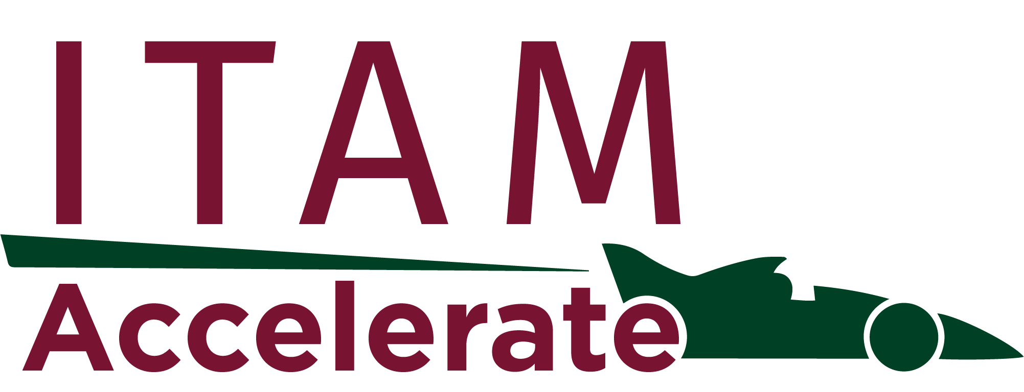

Comparing ITAM and FinOps/Cloud
Management Frameworks:

Governing the Full Estate

Table of contents

Table of contents 2

Introduction: Two Disciplines, One Problem 3

Section 1: What Each Framework Is Actually Doing 3
ITAM: Lifecycle Governance Across the Full Asset Population 3
FinOps/Cloud Management: Consumption Governance in a Real-Time Environment 4

Section 2: Where the Frameworks Converge 5

Section 3: Where the Frameworks Diverge 7
Governance Cycle: Periodic vs Continuous 7
Asset Identification: Physical and Contractual vs Tag-Based and Ephemeral 7
Role Architecture: Concentrated vs Distributed Accountability 8
Optimisation: Compliance-Driven vs Consumption-Driven 8

Section 4: Operating Model Recommendations 9
Option 1: Unified ITAM and FinOps Function 9
Option 2: Federated Model with Shared Data Layer 9
Option 3: ITAM as Governance Overlay 9

Section 5: Towards a Common Process Language 9

Conclusion 10

Introduction: Two Disciplines, One Problem
IT Asset Management and FinOps/Cloud Management have more in common than either community typically acknowledges. Both exist to answer the same fundamental question: are we getting value from what we are spending on technology? Both rely on accurate data, structured processes, defined accountability, and executive sponsorship. And yet, in most organisations, the two disciplines operate in separate silos — different teams, different toolsets, different governance cycles, and a vocabulary gap wide enough to cause real operational friction.
That friction has a cost. Cloud environments complicate traditional ITAM disciplines: software runs on infrastructure you do not own, licences flex with consumption, and spend can spike overnight without a purchase order in sight. Conversely, FinOps teams optimising cloud spend without ITAM context routinely miss the licensing implications of workload placement, miss compliance risk in BYOL (Bring Your Own Licence) scenarios, and lack the process rigour to sustain optimisation gains over time. The practitioner on either side who dismisses the other discipline as someone else's problem is, in practical terms, governing half an estate.
This paper uses the process architectures from the ITAM Accelerate HAM/SAM Process Kit and Cloud Process Kit — specifically the RACIU charts that map accountability and system usage across all processes in both kits — to provide a structured, side-by-side analysis of how the two frameworks are designed, where they converge, and where they genuinely diverge. The goal is practical: help professionals in both disciplines understand the other well enough to build a governance model that covers the full estate.

Section 1: What Each Framework Is Actually Doing

ITAM: Lifecycle Governance Across the Full Asset Population
The ITAM Accelerate HAM and SAM process kits cover 44 discrete processes across three tiers: Hardware Asset Management (12 processes), SAM Foundation (17 processes), and SAM Advanced (16 processes), plus the Vendor Audit Value Stream as a cross-cutting operational thread.
The framework is anchored to the ISO 19770-1 standard and structures asset management across the full lifecycle — from procurement and deployment through active management, optimisation, and disposal. Hardware processes govern the physical estate: purchase, deployment, stock management, loan equipment, support and maintenance, repair, lost and stolen device handling, disposal, verification, physical audit, and refresh. SAM Foundation processes govern the software layer: request, procurement, packaging, deployment, recycling and licence optimisation, licence pool management, software removal, JML (Joiners, Movers and Leavers), catalogue maintenance, data verification, orphan data, and reporting. SAM Advanced adds the strategic and governance layer: vendor onboarding, contract review and termination, compliance audit and validation, rationalisation, supplier management, risk management, QA, document management, and financial management planning.
The RACIU model used across the kit assigns five distinct designations: Responsible, Accountable, Consulted, Informed, and Used — with the "Used" designation specifically tracking which systems are engaged at task level. Typical system touchpoints across the HAM/SAM kit include a CMDB/Asset Register, SAM Suite, ITSM Suite, HR System, Supported Software Catalogue, Procurement Suite, and End-Point Management Suite. Role coverage spans ITAM Manager, ITAM Team, Procurement, Finance, IT Operations, Line Manager, End User, Vendor, Enterprise Architecture, Senior Management, and ITAM Sponsor, among others.
The dominant pattern in the RACIU assignments is ITAM-centric accountability: the ITAM Team and ITAM Manager hold the majority of R/A designations across both Foundation and Advanced processes. Finance and Procurement are regularly consulted or informed. Business stakeholders are mostly informed. Vendors are assigned responsibility for their own fulfilment steps but are rarely given accountability for outcomes.

FinOps/Cloud Management: Consumption Governance in a Real-Time Environment
The ITAM Accelerate Cloud Process Kit covers 26 processes organised around the disciplines of cloud operations, financial management, governance, and programme management. Processes range from Provisioning and Orchestration and Tagging Taxonomy management through to Cloud Financial Management, Consumption Forecasting, Chargeback/Showback, Contract Review, Risk Management, QA, and a full suite of programme management and document control processes that mirror the governance layer in SAM Advanced.
The system architecture in the Cloud RACIU chart reflects the different tooling environment: a Cloud Management Platform (CMP) is the primary operational system, with an ITSM Suite, Procurement Suite, GRC System, SAM Suite, FinOps/Cloud Maturity Assessment, Vendor Cloud Portal, Process Management System, and Vendor Management Suite all appearing as supporting systems. Notably, the SAM Suite appears as a "Used" system in the Cloud Contract Review Process — specifically at step 1.30, "Estimate Licensing Impacts" — which is one of the more explicit cross-framework integration points in the entire kit.
The role taxonomy in the Cloud kit is significantly broader and more distributed than in the HAM/SAM kit. Where ITAM concentrates accountability, cloud governance distributes it. The Cloud RACIU chart includes: Engineers, FinOps, Billing Centre Owner, Cloud Centre of Excellence (CCoE), Product Owner, Stakeholders, Business Owner, Finance, Vendor Management, Cloud Services Partner, Enterprise Architecture, Cloud Governance Sponsor, GRC, Risk Owner, Data Owner, Report Owner, HR, Document Owners, ITAM, Information Security, and ITSM. The FinOps role and the CCoE appear prominently as R/A holders across financial and optimisation processes. ITAM appears as a named role — consulted or informed — in processes such as Cloud Consumption Alert and Cloud Contract Review, but rarely as R/A.
This distributed accountability model reflects the fundamental design philosophy of FinOps: financial responsibility for cloud consumption belongs to the teams that generate it. The FinOps team acts as enabler and analyst, not controller.

Section 2: Where the Frameworks Converge
Figure 1 below illustrates the convergence and divergence of both process kits as a Venn diagram, with process references colour-coded by discipline.
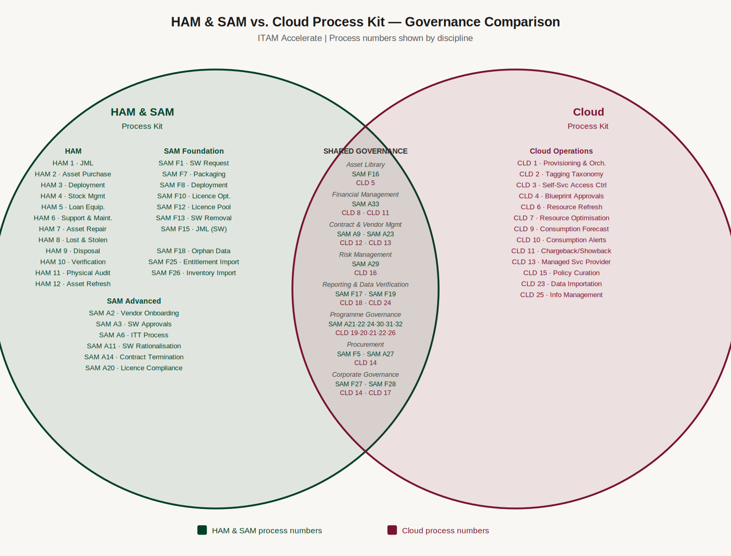
Figure 1: HAM & SAM vs. Cloud Process Kit — Governance Comparison

Asset Library Management
Both frameworks maintain a curated library of approved assets that teams can draw from, reflecting a shared principle that governance works best when it guides consumption at the point of request rather than auditing it after the fact. In the SAM kit, SAM Foundation Process 16 (Maintain a Supported Software Catalogue Process) establishes and curates the approved software catalogue — the authoritative list of what can be requested, deployed, and supported. In the Cloud kit, Process 5 (Maintain a Cloud Blueprint Library Process) performs the equivalent function for cloud resources, maintaining a library of approved, pre-validated infrastructure patterns that engineers can consume without requiring individual design approval. Both processes share the same governance logic: define what good looks like, keep the library current, and retire items that no longer meet policy. The vocabulary differs — catalogue versus blueprint library — but the intent is identical.

Financial Management as a Shared Discipline
Both kits contain explicit financial management processes, and the structural parallels are clear. The SAM Advanced kit includes Process 33: Financial Management Plan Process, which covers establishing financial baselines and budgets, tracking spend against entitlement, and reporting financial exposure from licence compliance risk. The Cloud kit includes Process 8: Cloud Financial Management Process — covering billing centre hierarchy definition, optimisation categories, shared cost schema, and forecasting methodology — alongside Process 9: Cloud Consumption Forecasting Process and Process 11: Cloud Chargeback/Showback Process.
The parallel is not cosmetic. Both processes are concerned with the same underlying question: what are we spending on technology assets, what are we expecting to spend, and where is the variance? The governance structures differ — ITAM anchors financial management to contractual entitlement, Cloud anchors it to consumption budgets — but the analytical objective is the same.

Contract and Vendor Management
SAM Advanced Process 9 (Contract Review) and Process 23 (ITAM Supplier Management) have direct counterparts in the Cloud kit: Process 12 (Cloud Contract Review) and Process 13 (Cloud Managed Service Provider Process). The Cloud Contract Review process at step 1.30 explicitly engages the SAM Suite to estimate licensing impacts — a designed integration point that acknowledges the BYOL and licence mobility considerations that apply when negotiating hyperscaler agreements. Microsoft Azure Hybrid Benefit, Oracle on AWS licensing, and similar scenarios cannot be accurately modelled without the SAM data layer that Process 12 calls on.

Risk Management
Both frameworks include dedicated risk management processes. SAM Advanced Process 29 (Risk Management Process) and Cloud Process 16 (Cloud Risk Management Process) share the same structural intent: identify, assess, escalate, and track technology risk. The difference is scope — SAM risk is primarily licence compliance and audit exposure, while cloud risk encompasses configuration drift, security posture, spend spike, and service dependency. In a mature hybrid estate, these risk registers should feed a single view; in most organisations, they do not.

Reporting and Data Verification
SAM Foundation Process 19 (Reporting Process) and Cloud Process 18 (Reporting Framework Process) both establish the cadence and ownership of performance reporting. Process 17 (Software Asset Data Verification) and Process 24 (Cloud Data Verification) both tackle the unglamorous but essential discipline of keeping the underlying dataset accurate. Both kits treat data quality as a process, not an assumption — which is one of the more important practitioner points of alignment between the two frameworks.

Programme Governance Processes
The governance layer of both kits is strikingly similar in structure. SAM Advanced includes processes for QA, Competence and Training, Awareness and Communications, Tooling Requirements and Verification, Document Creation and Management, and Information Management Planning. The Cloud kit mirrors this almost exactly: Cloud QA, Cloud Competence and Training, Cloud Awareness and Communications, Cloud Tooling Requirements and Verification, Cloud Document Management, and Cloud Information Management. The implication is that a mature ITAM professional moving into a cloud governance role will find the process architecture familiar — the vocabulary and tooling differ, but the governance logic is the same.

Corporate Governance
Both kits include explicit corporate governance processes that sit above individual discipline operations and connect the management system to the wider organisation. SAM Foundation Process 27 (Corporate Governance Process) and SAM Foundation Process 28 (Create and Maintain a SAM Plan Process) establish the organisational mandate and strategic planning cadence for ITAM. Their counterpart in the Cloud kit is Process 17 (Cloud Governance Framework Plan Process), which performs the equivalent function for cloud management — translating organisational policy into a documented governance framework with defined ownership and review cycles. All three processes share the same structural intent: ensure the discipline has a sanctioned plan, a named sponsor, and a mechanism for keeping governance commitments current. Organisations building an integrated ITAM and cloud governance model should treat these three processes as a single corporate governance workstream rather than separate planning exercises.

Section 3: Where the Frameworks Diverge

Governance Cycle: Periodic vs Continuous
The most fundamental operational difference between the two frameworks is time. ITAM operates on a periodic governance cycle: licence reconciliations run monthly or quarterly, audits are annual or triggered by vendor notification, inventory verification is scheduled. This is a rational response to the nature of the assets being managed — on-premise software licences do not change value overnight.
Cloud spend does. The Cloud kit's Provisioning and Orchestration Process, Consumption Alert Process, and Consumption Forecasting Process all assume a continuous, near-real-time governance model. Process 1 (Provisioning and Orchestration) includes Policy-as-Code testing at the point of resource creation — governance that fires before a resource goes live, not in a monthly reconciliation cycle. The Cloud Consumption Alert Process (Process 10) is designed to trigger on deviation from defined thresholds, not on a schedule.
This difference in tempo creates genuine organisational tension when ITAM and cloud teams are asked to share reporting cycles, tool selection, or governance forums. Neither is wrong; they are optimised for different asset behaviours.

Asset Identification: Physical and Contractual vs Tag-Based and Ephemeral
HAM processes 2 through 12 are built around assets with a persistent, physical identity: a serial number, a purchase order, a deployment record, a disposal certificate. The asset exists as a discrete, trackable object from procurement to disposal. SAM processes extend this to software: an entitlement has a purchase date, a media version, a licence pool entry, a reconciliation position.
Cloud resources are inherently ephemeral. A container spun up for a workload may exist for minutes. The Cloud kit responds to this by making the Tagging Taxonomy Process (Process 2) a foundational discipline — without accurate, consistent tagging, resource attribution to billing centre, product owner, and cost category breaks down entirely, and the financial management and chargeback processes built on top of it become meaningless. The SAM RACIU chart has no equivalent process, because the CMDB/Asset Register handles attribution through a different, persistent identity model.

Role Architecture: Concentrated vs Distributed Accountability
As noted above, the HAM/SAM RACIU chart concentrates accountability in the ITAM function. The Cloud RACIU chart distributes it across Engineers, FinOps, CCoE, Business Owners, Billing Centre Owners, and Product Owners. This is not a design flaw in either framework — it reflects the different operating models of the disciplines.
It does, however, create an integration challenge. When an organisation asks "who owns cloud licence compliance?", the HAM/SAM model would answer ITAM; the Cloud model would distribute accountability across FinOps (spend), ITAM (entitlement), and Enterprise Architecture (platform decisions). Getting that answer wrong — assigning it entirely to either team in isolation — guarantees a gap.
If we were to take this to an atomic level in an attempt to resolve who does what, and where, and when, and how – we could do worse than analyse: “who owns the data?” Our golden sources can be our best friends in this instance, as the owners of those golden sources will be most emotionally invested in keeping that data as tidy and as accurate as possible. Through data management, our process owners reveal themselves.

Optimisation: Compliance-Driven vs Consumption-Driven
SAM Foundation Process 10 (Software Recycling and Licence Optimisation) and Process 12 (Licence Pool Management) are both compliance-anchored: the objective is to ensure entitlement matches deployment, recover unused licences to pool, and reduce audit exposure. Optimisation is a compliance outcome.
Cloud Process 7 (Cloud Resource Optimisation) is consumption-anchored: the objective is to reduce unit cost and eliminate waste, independent of any compliance position. Step 1.1 captures usage reports, step 1.2 analyses for optimisation opportunity, step 8.1 implements policy-driven optimisation — this is a continuous value engineering cycle, not a compliance remediation. The two processes can generate conflicting recommendations in hybrid scenarios (for example, a BYOL workload might be licence-optimal but cloud-inefficient, or vice versa), which is precisely why cross-framework governance is required.

Section 4: Operating Model Recommendations

Option 1: Unified ITAM and FinOps Function
The most integrated model places ITAM and FinOps under a single Technology Business Management or IT Governance function, with a shared data layer (CMDB, SAM Suite, CMP) and unified reporting. This model works well when the organisation has a mature ITAM capability being extended to cover cloud, or where cloud spend is dominated by IaaS/PaaS with significant BYOL licensing complexity. The HAM/SAM and Cloud process kits can be operated in parallel under shared programme governance processes — the structural similarity of their QA, competence, document management, and information management processes facilitates this. The practical challenge is finding practitioners with credibility in both disciplines; they exist, but they are not common, and organisations should plan for a transition period where subject matter expertise is deliberately shared across team boundaries rather than assumed.

Option 2: Federated Model with Shared Data Layer
The more common real-world pattern is a federated model: ITAM owns on-premise and SaaS entitlement governance, FinOps owns cloud consumption governance, and a shared data layer (CMP feeding the SAM Suite, or a dedicated ITAM/FinOps integration layer) provides the cross-reference capability needed for hybrid licence decisions. The Cloud Contract Review Process (Process 12, step 1.30) is the primary designed integration point in this model — ITAM data is consumed by cloud governance at the point of vendor negotiation; cloud license consumption data is consumed by ITAM during compliance analysis and reporting.

Option 3: ITAM as Governance Overlay
In organisations where FinOps is well-established but ITAM maturity is lower, a pragmatic approach is to position ITAM as a governance overlay on FinOps operations: contributing licence entitlement data, vendor audit response capability, and compliance risk assessment, without attempting to subsume the FinOps operating model. In this configuration, ITAM appears in the Cloud RACIU chart exactly as it does — as a consulted or informed party in financial and contract processes, with the heavier ITAM governance processes operating on their own cadence.

Section 5: Towards a Common Process Language
The structural similarity between the governance layers of the HAM/SAM and Cloud process kits is not accidental. Both are built on a common process architecture: plan, operate, verify, report, govern. The differences are in the asset object, the governance tempo, and the role distribution — not in the fundamental logic of how a process-based management system is constructed.
This creates a real opportunity. An organisation that has invested in ITAM process maturity has already built the governance muscles — the process documentation, the RACIU accountability model, the QA and audit discipline, the programme governance cadence — that cloud management also requires. The translation from ITAM to cloud governance is not a reinvention; it is a re-parameterisation. The ITAM professional brings process rigour that most cloud teams lack. The FinOps professional brings consumption analytics and financial engineering capability that most ITAM teams lack. Neither is complete without the other.
The RACIU chart is itself a useful lens here. When the Cloud kit assigns "ITAM" as a consulted or informed party in processes like Cloud Contract Review and Cloud Consumption Alert, it is not marginalising the ITAM function — it is recognising that ITAM holds data and expertise that cloud governance depends on, without requiring ITAM to own the cloud governance process outright. That is the integration model in microcosm: each discipline contributing its core competency to a shared outcome, with clear accountability assigned at the task level rather than debated at the organisational level.
The path forward for both disciplines is the same: a standard-agnostic governance platform capable of modelling, tracking, and evidencing process compliance across both frameworks — and across the AI management and GRC frameworks that are now joining the estate governance landscape alongside them.

Conclusion
The ITAM and FinOps/Cloud frameworks are not competitors. They are complementary governance systems built for different asset behaviours in the same technology estate. The process kits examined in this paper — 44 HAM/SAM processes and 26 Cloud processes, mapped through the RACIU accountability model — demonstrate both the depth of alignment and the genuine operational differences that practitioners in each discipline need to understand.
For the ITAM professional: cloud governance is not alien territory. The process architecture is familiar, the governance disciplines are recognisable, and the data skills translate. The primary adjustment is from periodic to continuous governance, and from concentrated to distributed accountability. The RACIU model you use to map software asset management accountability applies directly to cloud process design — the role taxonomy is broader, but the underlying logic of who is responsible, who is accountable, who needs to be consulted, and who needs to be kept informed is the same discipline you already practise.
For the FinOps and cloud management professional: ITAM is not legacy overhead. The entitlement management discipline, the contract and vendor governance rigour, and the compliance risk framework that ITAM brings are prerequisites for managing the licensing complexity that increasingly pervades cloud environments — particularly as hyper-scaler agreements, BYOL workloads, and SaaS proliferation make the boundary between "cloud cost" and "software licence" progressively harder to draw. The Cloud Contract Review process in the Cloud kit already assumes ITAM input at the licensing estimation step. That dependency is a signal, not an accident.
Organisations that bridge the two disciplines — through a unified function, a federated model, or a common governance platform — will govern their full technology estate more effectively than those that leave the two silos in place. The process infrastructure to do so already exists. The remaining challenge is organisational will and cross-discipline literacy, both of which start with practitioners on each side making the effort to understand how the other half of the estate is governed.

This paper references process architectures from the ITAM Accelerate HAM/SAM Process Kit (V3.1) and Cloud Process Kit (April 2026). RACIU designations cited are drawn from the published RACIU charts for both kits.
© ITAM Accelerate

